Question : 1
Install NumPy in your Python environment using pip, then create a Python file called insta_likes.py and import numpy as np at the top :

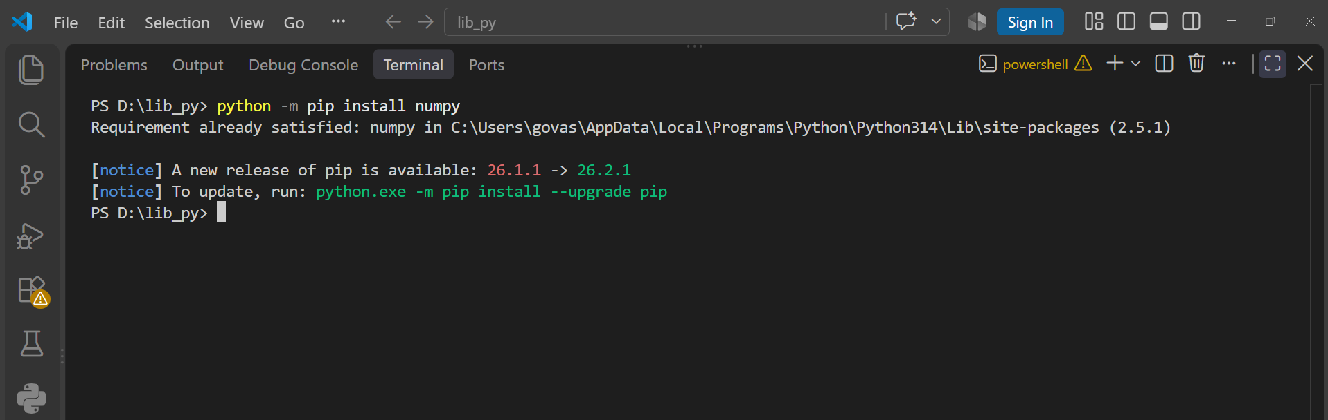
python -m pip install numpy
import numpy as np
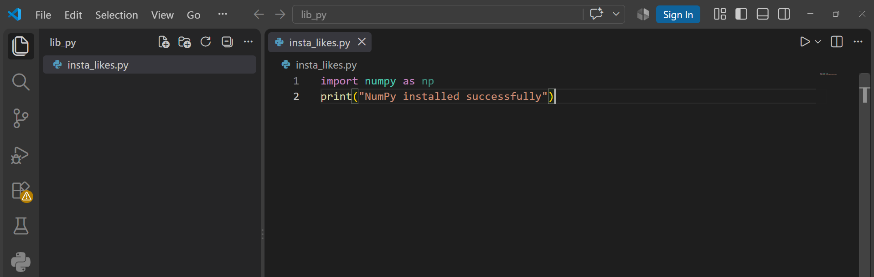
print("NumPy installed successfully")
Question : 2
Create a NumPy array called followers using np.array() that stores the follower counts for 5 Instagram influencers: [1200, 15000, 67000, 340000, 1250000]. Print the array, its shape, number of dimensions, and data type :

import numpy as np
followers=np.array([1200,15000,67000,340000,1250000])

print(followers)
print(f"Shape:{followers.shape}")
print(f"Dimensions:{followers.ndim}")
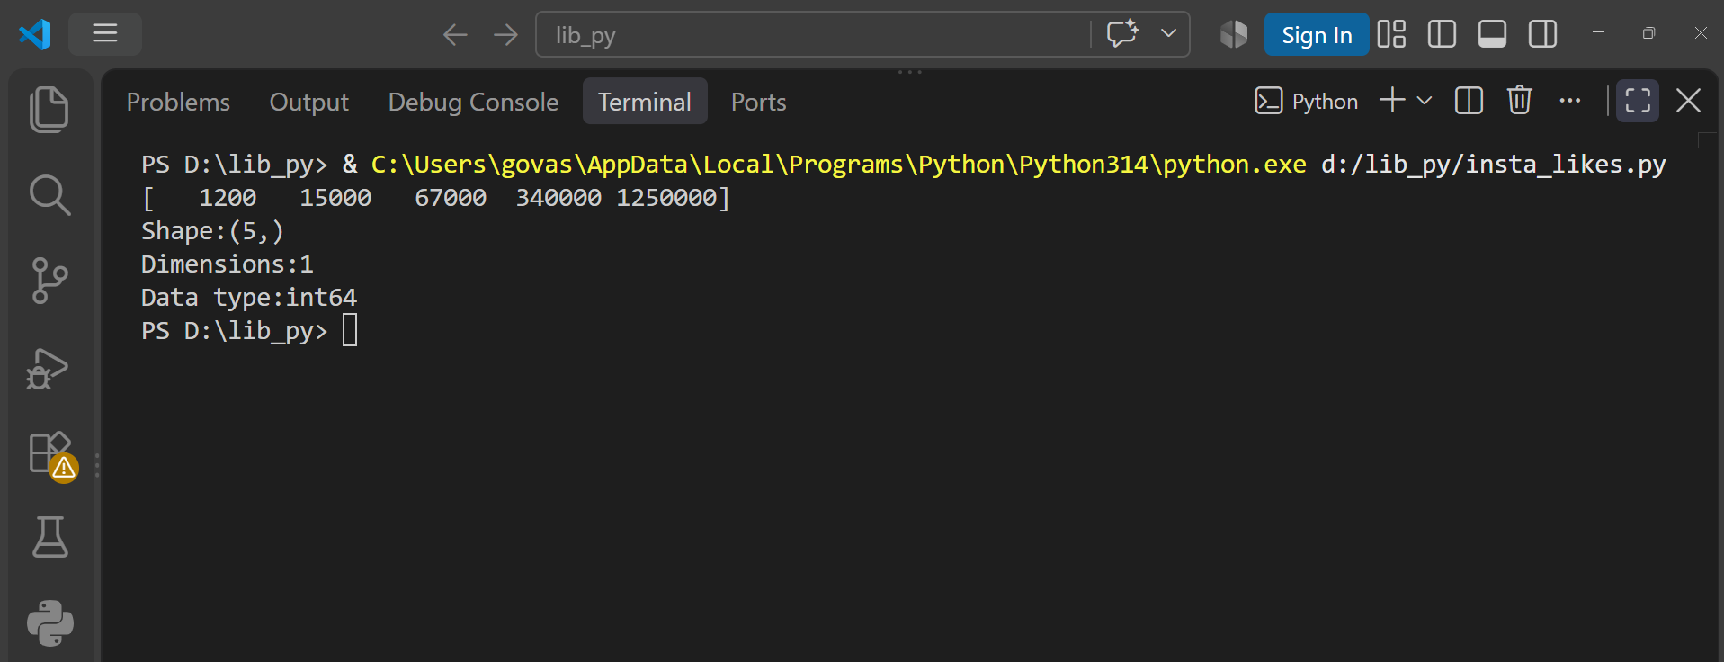
print(f"Data type:{followers.dtype}")

Question : 3
Use np.arange() to generate an array of order IDs for 10 consecutive Zomato orders starting from 101. Print the array and its size :

import numpy as np
order_ids=np.arange(101,111)

print(f"Order IDs:{order_ids}")
print(f"Size:{order_ids.size}")
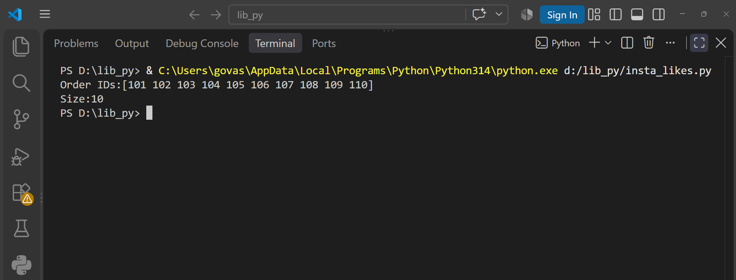

Question : 4
Create a 3x3 NumPy array using np.eye() to represent a 'like' identity matrix for a new Spotify playlist feature. Print the matrix and explain what the diagonal values represent in a comment :

import numpy as np
like_matrix = np.eye(3)
print("Like Identity Matrix:")
print(like_matrix)
# Diagonal values represent each feature liking itself.
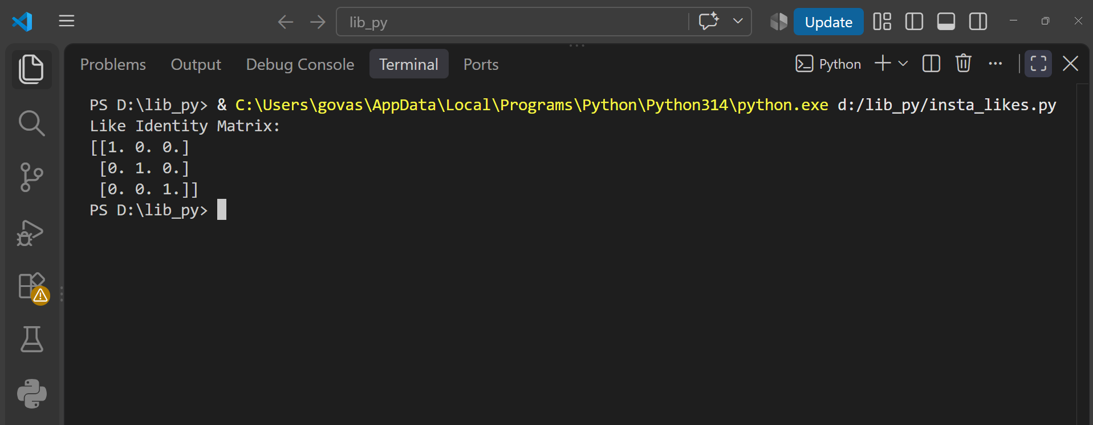

Question : 5
Convert a Python list of cricket scores [45, 67, 120, 89, 54] to a NumPy array, then use the .itemsize attribute to print how many bytes each score takes in memory.<br><br><em><strong>Hint:</strong> Use np.array() for conversion and .itemsize for memory size :</em>

import numpy as np
scores =[45,67,120,89,54]
scores_array= np.array(scores)
print(f"Cricket Scores:{scores_array}")
print(f"Bytes per score:{scores_array.itemsize}")
